
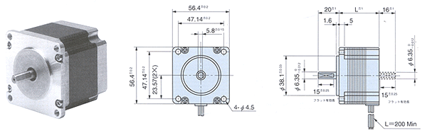
形式  Model No. |  | 基本  步級角  Deg.  Step Angle | 額定  電壓  V/Phase  Voltage | 額定  電流  A/Phase  Current | 線圖  阻抗  /Phase  Resistance | 線圖  感抗  mH/Phase  Inductance | 激磁最大靜止力矩  N-m(kgf-cm)  Holding Torque | 馬達長 L  mm  Motor Length | 轉子  慣量  x10⁻⁷kgm²  Rotor Inertia | 重量  (g)  Weight
單軸  Single Shaft | 雙軸  Double Shaft
TS3653N1E1 | TS3653N11E1 | 1.8 | 5.2 | 1 | 5.2 | 5.4 | 0.39(3.9) | 39 | 120 | 0.45
TS3653N1E2 | TS3653N11E2 | 1.8 | 2.8 | 2 | 1.4 | 1.4 | 0.39(3.9) | 39 | 120 | 0.45
TS3653N1E3 | TS3653N11E3 | 1.8 | 1.9 | 3 | 0.63 | 0.6 | 0.39(3.9) | 39 | 120 | 0.45
TS3653N2E4 | TS3653N12E4 | 1.8 | 7.2 | 1 | 7.2 | 11 | 0.9(9) | 54 | 260 | 0.7
TS3653N2E5 | TS3653N12E5 | 1.8 | 3.6 | 2 | 1.8 | 2.5 | 0.9(9) | 54 | 260 | 0.7
TS3653N2E6 | TS3653N12E6 | 1.8 | 2.3 | 3 | 0.75 | 1.2 | 0.9(9) | 54 | 260 | 0.7
TS3653N3E7 | TS3653N13E7 | 1.8 | 8.2 | 1 | 8.2 | 14 | 1.35(13.5) | 76 | 430 | 1
TS3653N3E8 | TS3653N13E8 | 1.8 | 4.5 | 2 | 2.25 | 3.6 | 1.35(13.5) | 76 | 430 | 1
TS3653N3E9 | TS3653N13E9 | 1.8 | 3 | 3 | 1 | 1.6 | 1.35(13.5) | 76 | 430 | 1
TS3653N4E12 | TS3653N14E12 | 1.8 | 2.2 | 5 | 0.44 | 1.4 | 2(20) | 84 | 520 | 1

