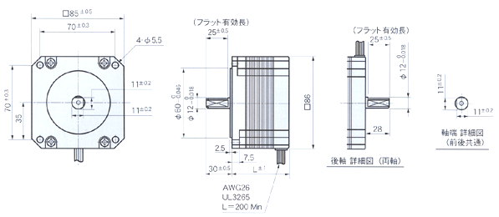
形式  Model No. |  | 額定  電壓  V/Phase  Voltage | 額定  電流  A/Phase  Current | 線圖  阻抗  /Phase  Resistance | 激磁最大靜止力矩  N-m(kgf-cm)  Holding Torque | 馬達長 L  mm  Motor Length | 轉子  慣量  g‧m²  Rotor Inertia | 重量  (g)  Weight | 0
單軸  Single Shaft | 雙軸  Double Shaft
TS3630N1E1 | TS3630N21E1 | 2.46 | 1.4 | 1.76 | 2.1(21) | 64.5 | 900 | 1800 | 0
TS3630N1E2 | TS3630N21E2 | 2.1 | 2.8 | 0.57 | 2.1(21) | 64.5 | 900 | 1800 | 0
TS3630N2E3 | TS3630N22E3 | 3.82 | 1.4 | 2.73 | 4.1(41) | 96.5 | 2000 | 3000 | 註1
TS3630N2E4 | TS3630N22E4 | 1.88 | 2.8 | 0.67 | 4.1(41) | 96.5 | 2000 | 3000 | 0
TS3630N1304E9 |  | 4.76 | 1.4 | 3.4 | 6.3(63) | 126.5 | 3000 | 4000 | 0
TS3630N3E5 | TS3630N23E5 | 2.38 | 2.8 | 0.85 | 6.3(63) | 126.5 | 3000 | 4000 | 註2

