SB / RB系列規格
型號\型號 | 連續出力轉矩  (kgf*m) | 最大出力轉矩  (kgf*m) | 出力軸容許徑向力(kgf) | 慣性矩  (單一速比) (kg*cm2) | 人力軸孔徑  (mm) | L1量(kg) | L2量(kg)
SB60 | 1.5 | 3 | 60 | 0.306 | 3~11 | 1.1 | 1.4
SB90 | 7 | 14 | 150 | 0.73 | 8~19 | 3.6 | 4.9

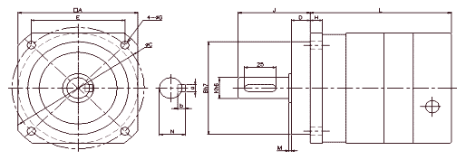
 | A | Bh7 | C | D | E | G | H | J | Kh6 | M | N | a | B | i | L1 | L2 | L3
SB90 | 9.5 | 80 | 105 | 15 | 74.2 | 4*6.8 | 10 | 57 | 18 | 2 | 20.5 | 6 | 6 | 25 | 109.5 | 137 | 164.5

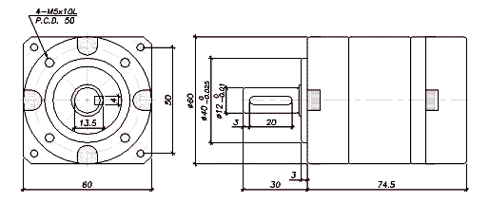
 | A | Bh7 | C | D | G | J | Kh6 | M | N | a | B | i | L1 | L2 | L3
SB60 | 60 | 40 | 50 | 3 | M5*10L | 30 | 12 | 1 | 13.5 | 4 | 4 | 20 | 74.5 | 93 | 111.5

減速比(Ratio Table of Gear Reducer):
型號(Model No.)\段數(Stage No.) | L1 | L2 | L3
SB60  SB90 | 3,4,5,7,10 | 9,12,15,16,20,21,25,28,  30,35,40,49,50,70,100 | 36,45,60,  75,80,120

